**IProject:**

**Online Aptitude Test System**

**Name : Muhammad Shiraz Batch code : 201408g**

**Student ID : 772628 Teacher Name : Sir Irtaza**

**Certificate Of Completion**

This is to certify that this report embodies the original work done by Muhammad Shiraz and during this project submission as a partial fulfillment of the requirement for the project titled as Online Aptitude Test System. The above students have completed their tasks as per given time and requirements.

**Acknowledgement**

We are thankful to almighty Allah that by his grace we have successfully completed our iProject. We are also thankful to our class teacher Sir Irtaza for his great support in successful completion of our project.

We have tried our best to fulfill the entire requirement given by the authority to make the project more comprehensive.

This is our 2nd semester project. We have tried our best & worked really hard for a better outlook to come. This project has been developed in Net Beans IDE 8.0.1. We have been assigned to make Software based on APTITUDE TEST SYSTEM as a project.

We really believe that this project will provide all the necessary information required by the authority to fulfill their requirements. However, suggestions for importance of the project will be received thankfully and acknowledged.

Regards,

Mr.Muhammad Shiraz

**APTITUDE TEST SYSTEM**

**IProject Introduction**

**APTITUDE TEST SYSTEM** ability are designed to assess your logical reasoning or thinking capabilities. They consist a Character of multiple choice question and are strictly timed.

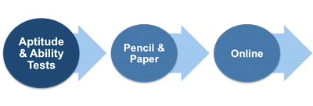

You may be asked to answer the questions either on paper or online. The advantages of online testing include immediate availability of result and test can be taken at an employment agency or even at home. This makes online testing particularly suitable for initial screening as it is very cost-effective.

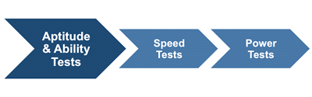

Aptitude and ability tests can classified as speed tests or power tests. In speed tests the question are relatively straightforward and the test is concerned with how many questions you can answer correctly in the allotted time. There tests tend to be used in selection at the administrative and clerical level. A power test on the other hand will present a smaller number of more complex questions and tend to be used more at the graduate, professional or managerial level.

**Functional Requirements:**



1. The details of the Exam Panel, Student Result, and Student Details are to be maintained and controlled solely by the (Manager) Admin alone.

2. The Student can change alone the password assigned to him.

3. Also first the student needed to login first in order to perform the student window.

4. Calculations of the mcqs test and by the application alone as designated by the Admin

5. The details of the student and update available are to be maintained and can be updated regularly (of course only by the admin)

6. Feed back form, Comments form and the Contact us forms.

7. There should be new, update, cancel and search options available.

**Preface**

We start with the name of Allah, the most beneficent, the most merciful who gave us eligibility to complete this project.

We are very grateful to our respected Teachers, who contributed with us for the completion of this project. First of all, we would like to thanks our respected Teacher ***Sir Irtaza*** of Aptech for her expert advice.

Moreover, we would like to thanks all the teachers of Aptech and our classmates for their kind appreciation and moral support.

We would like to express our deepest gratitude to our parents and well-wishers whose prayers and motivation enabled us to turn our dream into reality. Special thanks to our parents who supported us day and night for our project. **Finally** our sincere thanks to our teacher ***Sir Irtaza*** for all their assistance, help and support in making a document into reality of a website.

**Acknowledgement**

We are very thankful to Almighty, ALLAH that by His grace we have been successfully submitted our project. We are presenting our project, prepared on **Net Beans** to you. We have tried our best to take all relevant important topics in consideration so that this project may become comprehensive.

This is our **2nd Semester I** project. We have tried our best & struggled hard for a better outlook to come. This project is prepared on **Net Beans.** We chose to make Software for ***Aptech*** as a project. We found it easy to do our work on **Net Beans.**

We are hopeful that this project will provide all the necessarily information required by the user to fulfill their inspiration. However suggestions and advices for improvement of this project will be thankfully received & acknowledged.

**Thank You**

**PROJECT PLAN**

**Purpose of Plan: - APTITUDE TEST SYSTEM**

**Database**:

AptitudeTestSystem

**Basic Designing**:

Muhammad Shiraz

**Coding**:

Muhammad Shiraz

**Advance Designing**:

Muhammad Shiraz

**Documentation**:

Muhammad Shiraz

**The Project Plan defines the following: -**

• Project Purpose

• Online Test and Project Goals and Objectives

• Score and Expectations

• Roles and Responsibilities

• Assumptions and Constraints

• Project Management Approach

• Ground Rules for the Project

• Project Budget

• Project Timeline

**Snapshots**

Login Bar

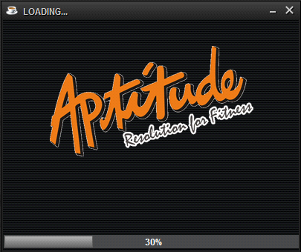

Login Panel

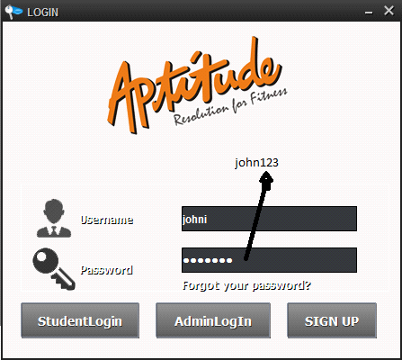

Student:

Username: johni

Password: john123

Student Window



Select Subject

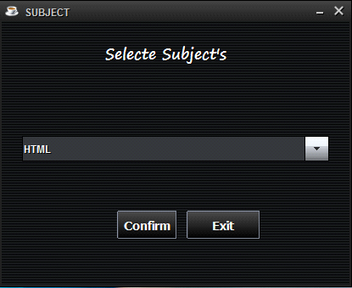

Exam Panel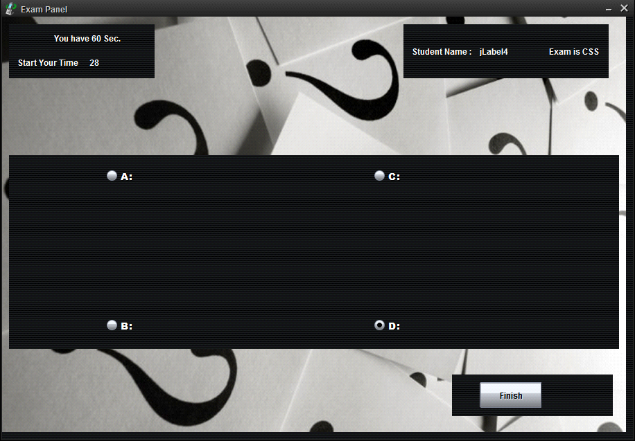

Student Result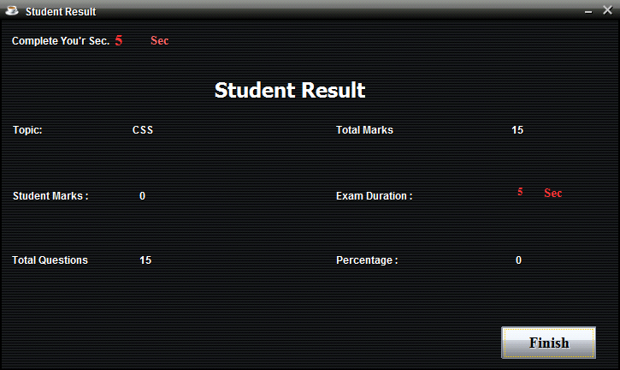

View Student Details

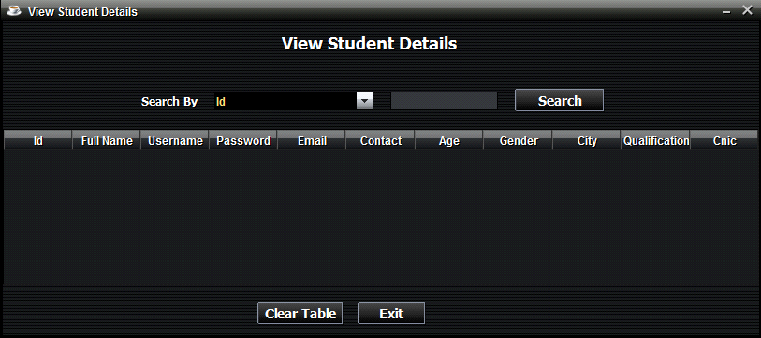

Update Student

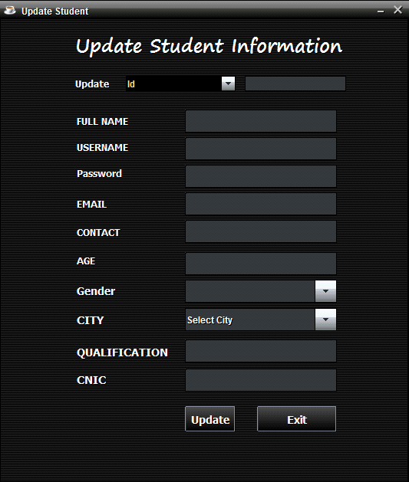

Feed Back

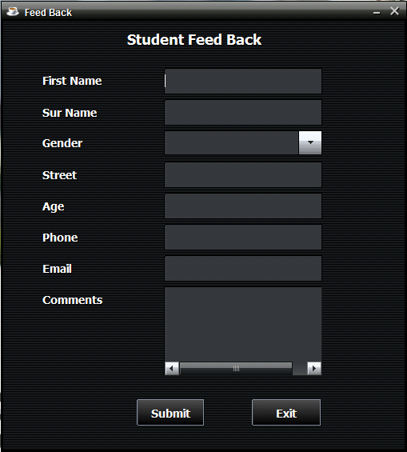

Contact US

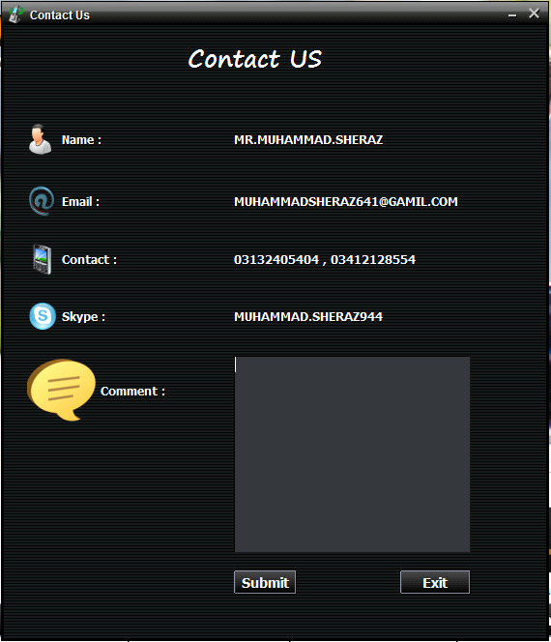

Change Password

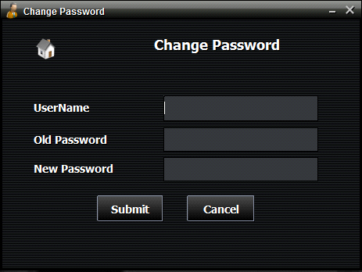

Admin Window

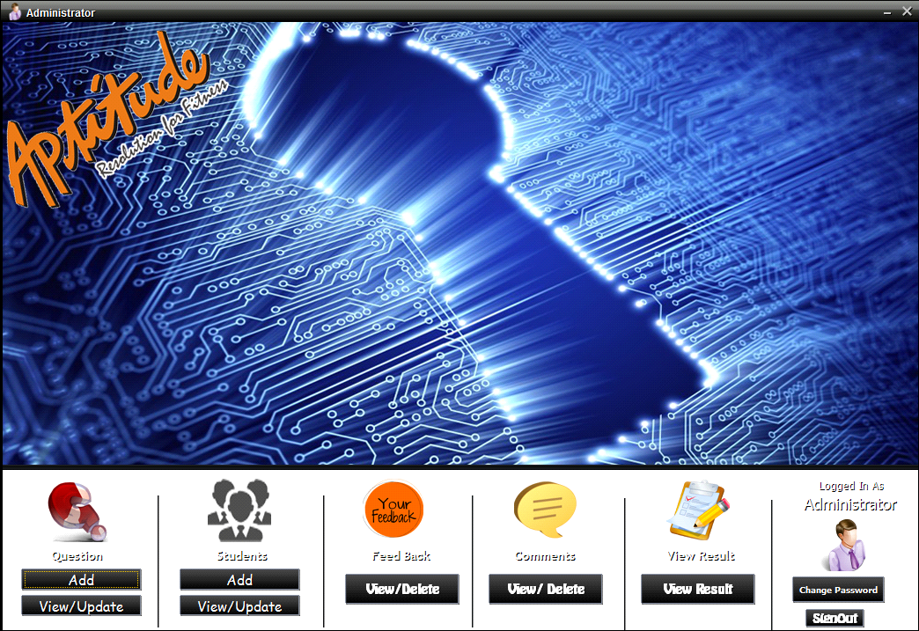

Admin:

Username: admin

Password: admin55

Add Question

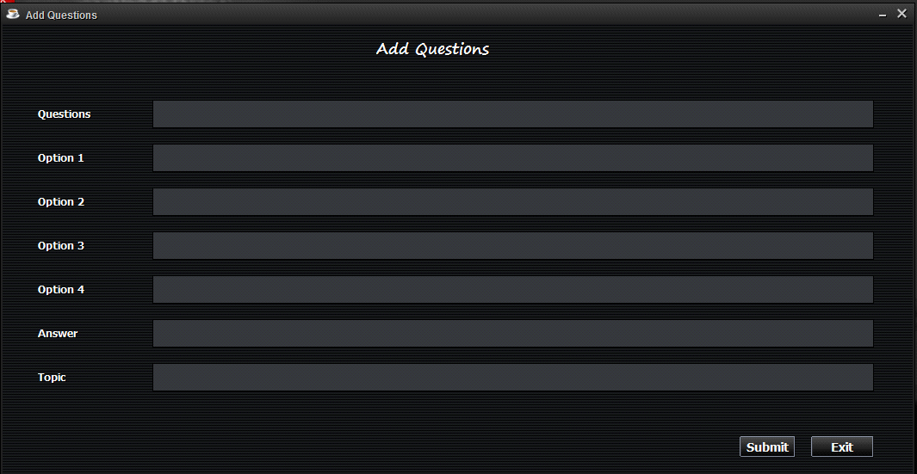

View & Update Questions Details

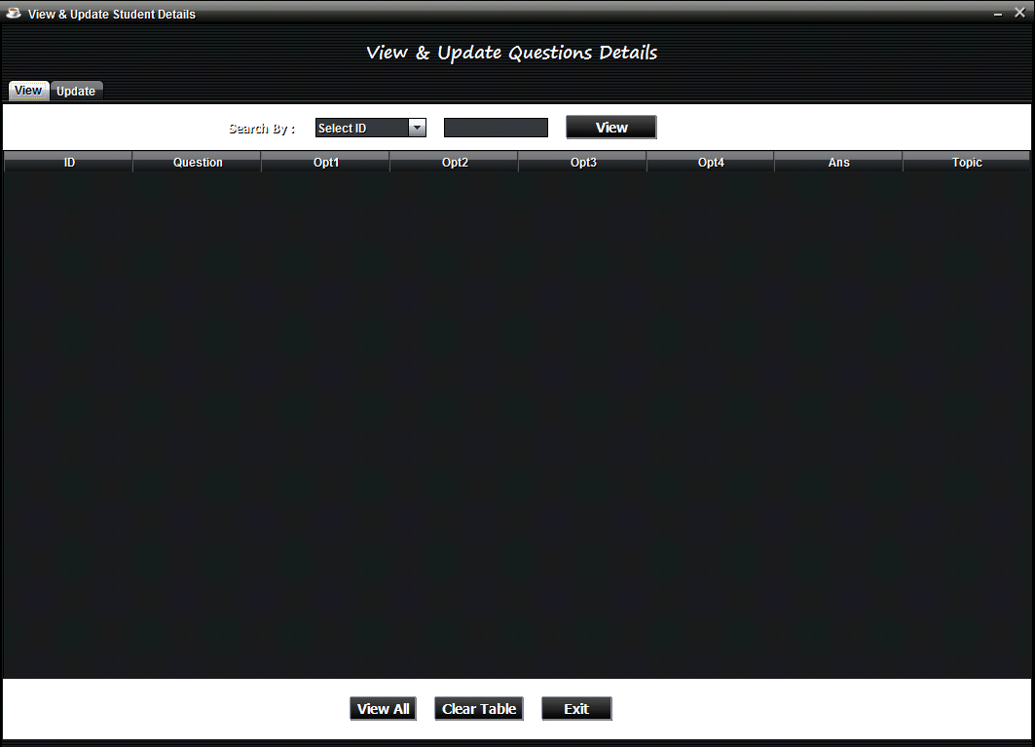

Add Student

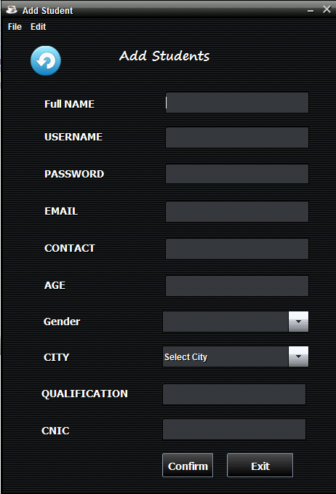

Comments

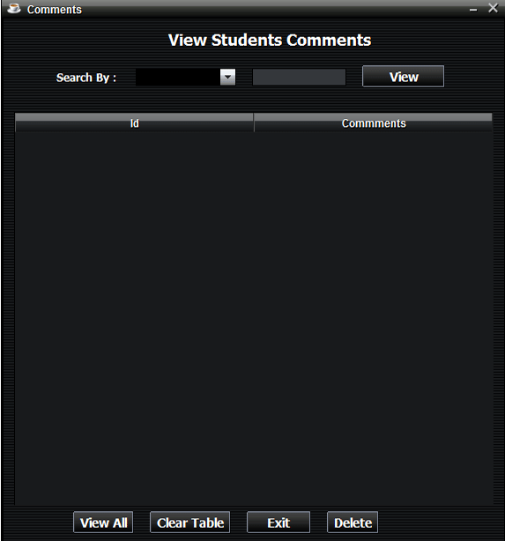

Student Result

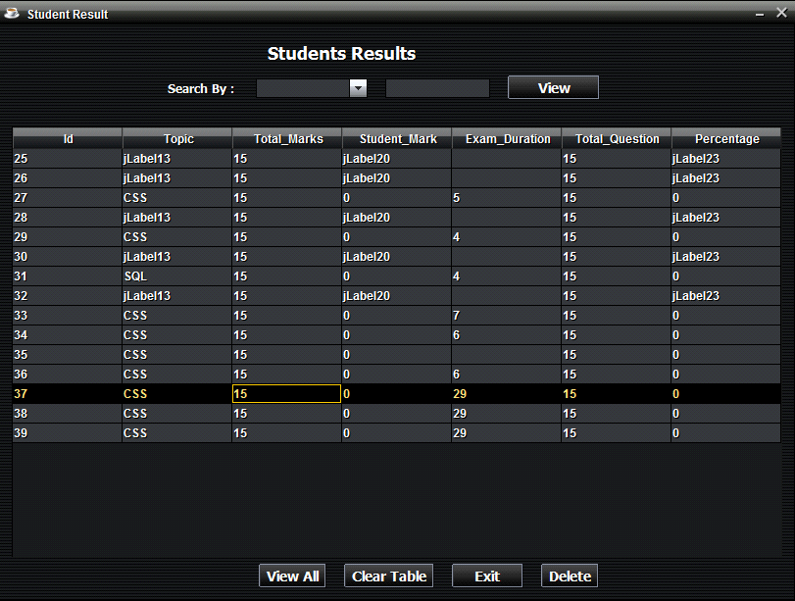

Admin Password

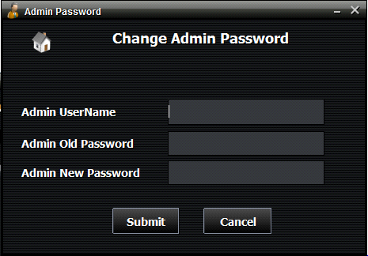

**FUTURE SCOPE**

Online Aptitude System has as many Future Scope as think of some of the few point have come to light. They are as follows: -

* Launching the software on the Network.
* Using JAVA programming on Higher scale using Hardware
* Programming such as Online Bus Ticket Reservation

**Hardware/Software requirements:**

**Hardware**

* A minimum computer system that will help you access all the tools in the courses is a Pentium D 1.2Ghz or better
* 2048 Megabytes of RAM or better
* Windows Xp(or higher if possible)
* Java Virtual Machine

**Software**

**Either or combination of the following Software’s are to be used:**

* Notepad/HTML editor/Java editor
* j2sdk1.4.1_02 (or later)
* SQL Server 2005/2008 RTM
* JDBC Driver

**User Guide**

* System Requirements:

|  |  |  |
| --- | --- | --- |
| **No.** | **Items** | **Description** |
| 1 | Operating System | Window 98,2000,XP etc |
| 2 | Main processor | Minimum 166 or better |
| 3 | Ram (Memory) | Minimum 64 or better |
| 4 | Software | Net beans/Text pad/Notepad/  Sql/Cmd |

**There is One Admin:**

1: username: Admin

2: Password: admin55

**There are Many Users:**

1: Username: johni

Password: john123

**For Net Beans:**

* Open Net Beans and Open Aptitude Test System
* Add **Sqljdbc4.jar** to the library
* Now run login.java file.

